Sprint 4 Plan

Plan-it

Team Rocket

12/1/2019

Revision 2, 11/30/2019

<https://app.clubhouse.io/teamrock/epic/37/plan-it?label_ids=105>

High level goal: *System test entire project, and improve main algorithm.*

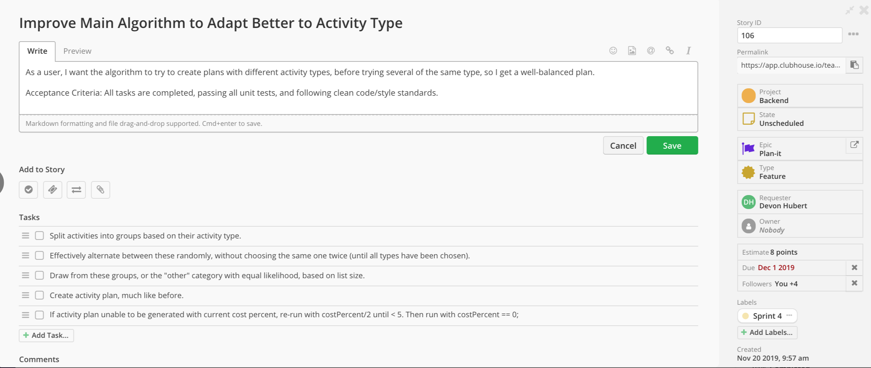

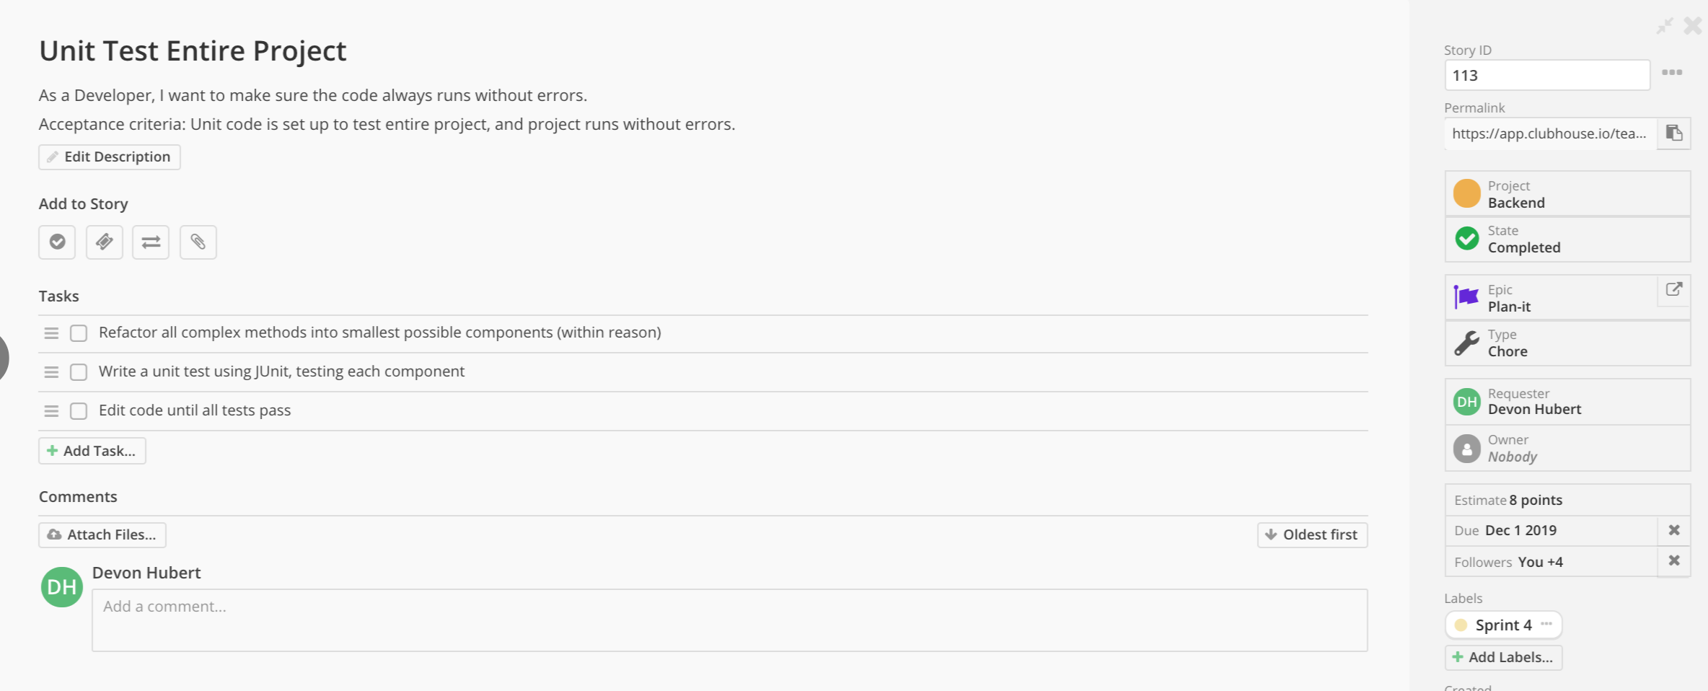

Meeting times: Monday, Wednesday, and Friday at 11:30. TA meeting on Wednesdays at 10:30 in room 316.